St. Saviour’s Dabble Day
Wednesday 6th December 11.00 a.m. to 2.00 p.m.
(Coffee served from 10.30 a.m.)

A chance to have a go at something you might not have done before, or may like to try again – and have something to take home to show for your efforts.

The day starts at 10.30 a.m. with tea/coffee and biscuits.

The first session starts at 11.00 a.m. until 12 noon; lunch from 12 noon to 1.00 p.m. then the afternoon session from 1.00 to 2.00 p.m.


The crafts to choose from are –

Ivy Wreath: Using fresh ivy woven around a frame and embellished.
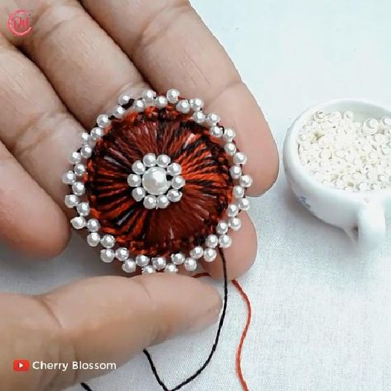

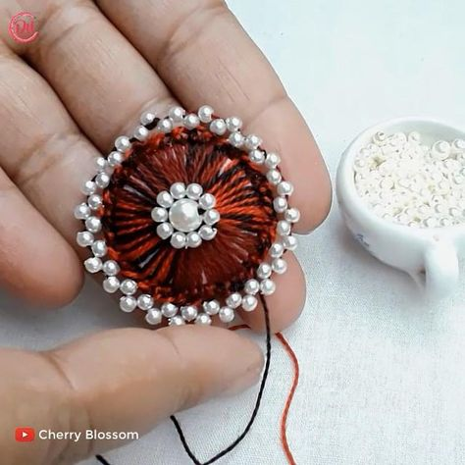
Christmas button and bead decoration: make a lovely decoration using buttons, beads, thread and snowflake.
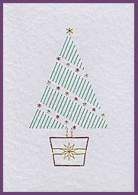

Stitched cards: make a Christmas greetings card using the long stitch, embroidery on paper method. A card will be marked with a pattern, outlined in holes. Using coloured threads, you will pull the threads through the holes to make a beautiful patterned card.


Hanging Heart decoration: Make a mobile from paper strips, staples and thread
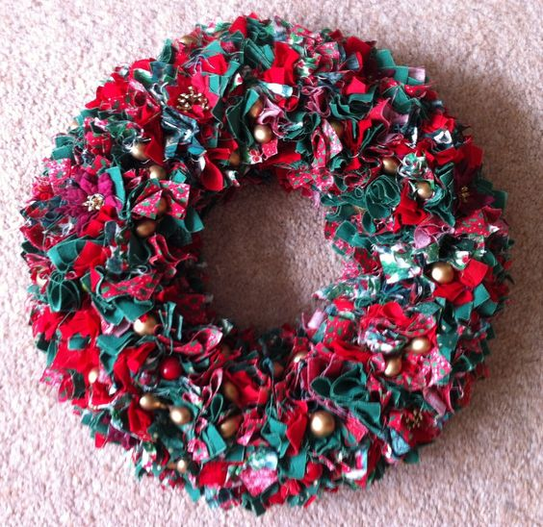

Fabric Wreath: Make a colourful wreath using scraps of material pushed into a polystyrene ring base.

The cost for the day to include all materials and refreshments is £15 (£1 extra for the ivy wreath). You can choose 2 of the above activities -1 in the morning and 1 in the afternoon. If, however, you would prefer to attend just one part of the day, that is fine, so just pay for what you attend. We do ask you to book so we make sure we have the necessary materials ready – and enough food!

